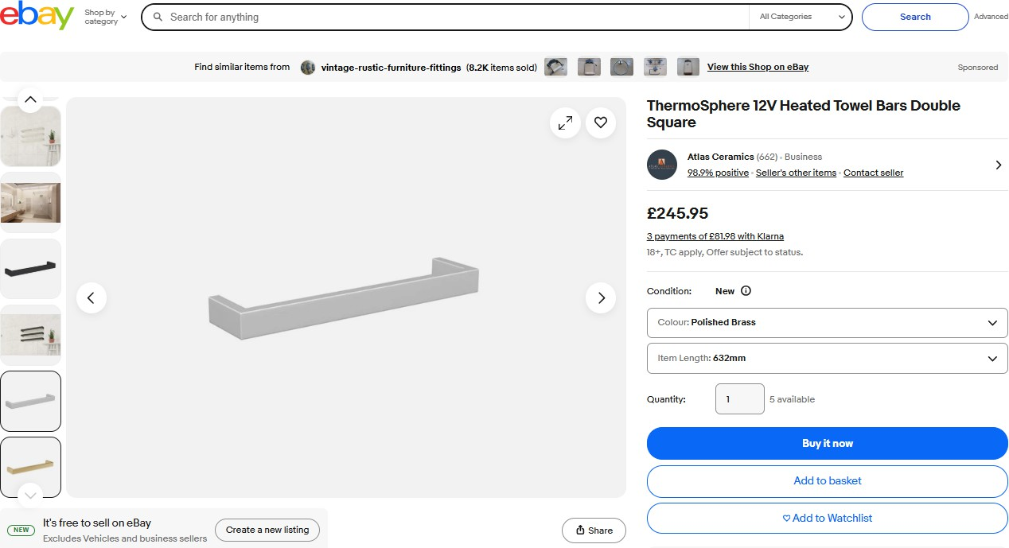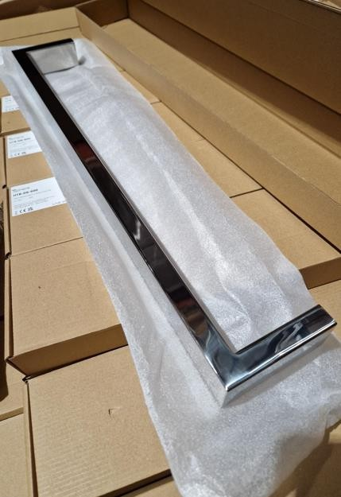

Listing is example of the same stock but ours is 600mm not 632mm

149pcs x Thermo Sphere Bespoke 12v 36w Heated Towel Bar – Stainless Steel…………Similar selling on eBay for £245.95

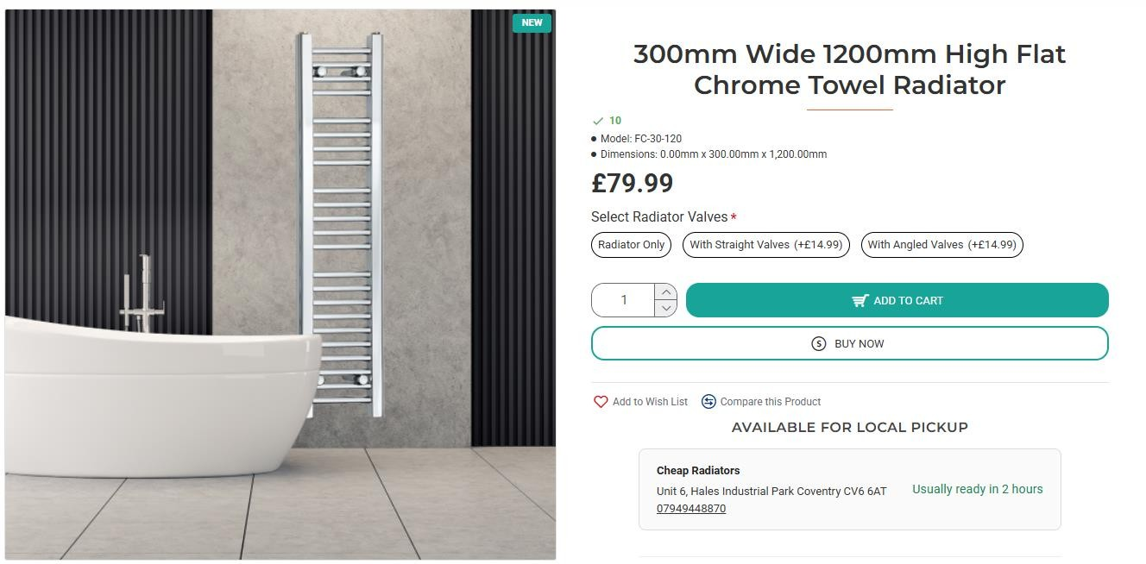

40pcs x Sphere Flat Chrome Towel Radiator (300mm x 1200mm)……………RRP £79.99

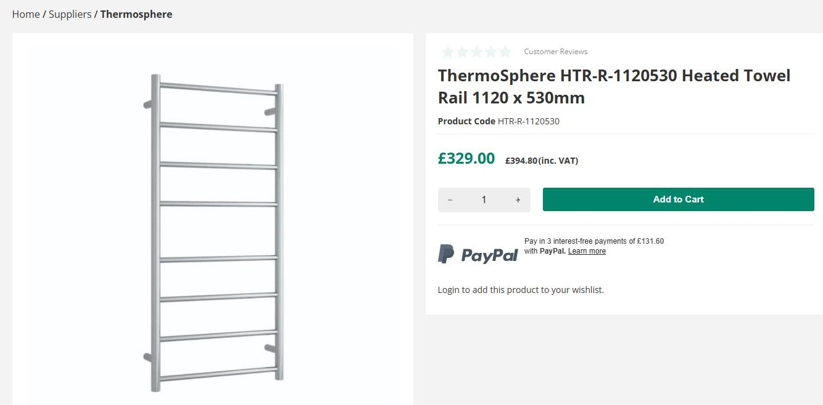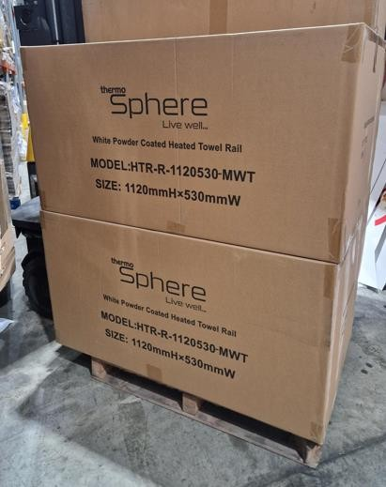

67pcs x Thermo Sphere Heated Towel Rail (1120 x 530mm) – Stainless Steel……….RRP £329
26pcs x Thermo Sphere Heated Towel Rail (1120 x 530mm) – Matt White……….RRP £329

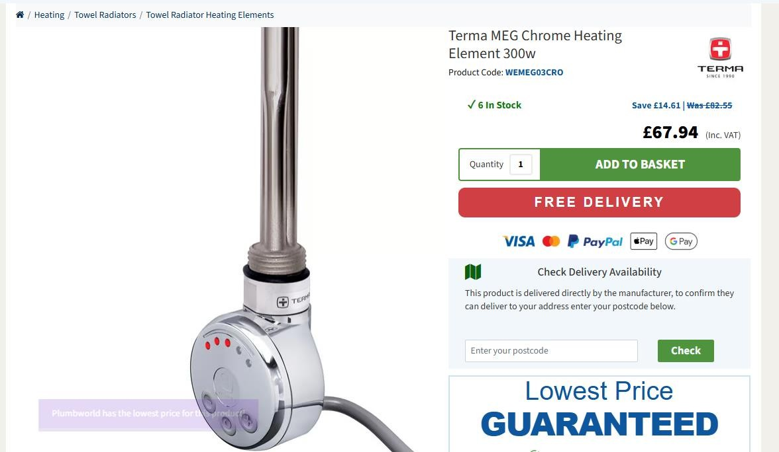

131pcs x Terma MEG Chrome 300w Element……….Original RRP £82.55

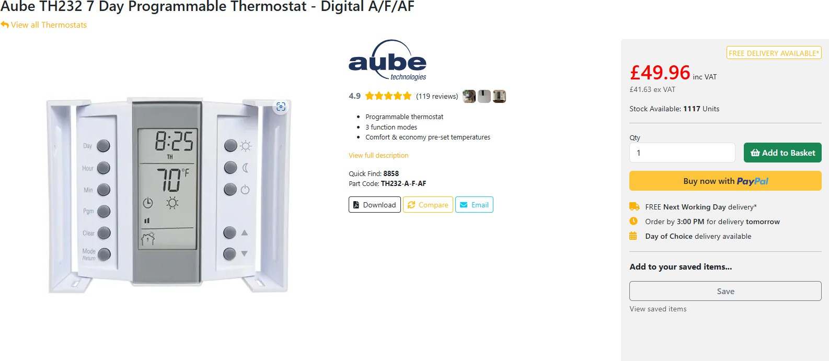

150pcs x Aube TH232 Programmable Thermostat………….RRP £49.96

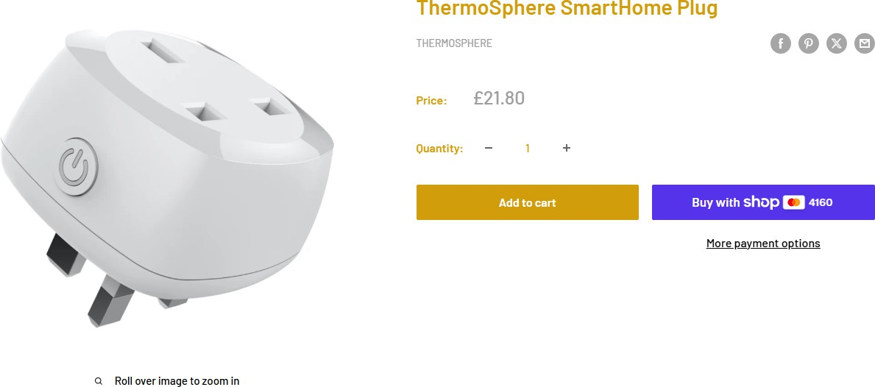

410pcs x ThermoSphere Smart Home Plug…………RRP £21.80

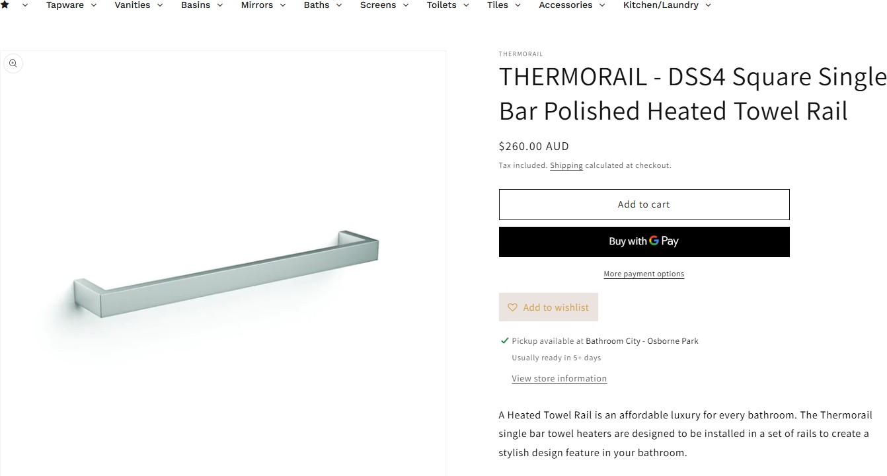

101pcs x Thermorail DSS4 Square Single Bar Polished Heated Towel Rail 17W – Matt Black………RRP $260 AUD

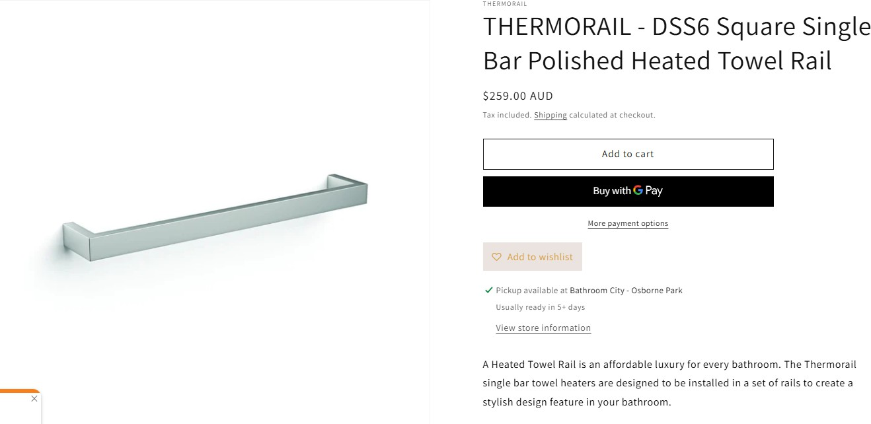

66pcs x Thermorail DSS6 Square Single Bar Polished Square Single Bar Polished Heated Towel Rail………RRP $259 AUD

